

**ADDIS ABABA UNIVERSITY**

**ADDIS ABABA INSTITUTE OF TECHNOLOGY**

**Department of Electrical and Computer Engineering**

**Data Communication and Computer Networking**

**Project two**

**Name ID.No. Stream**

**Belayneh Mathewos ATR/3742/07 Computer IV**

**Selamu Abo ATR/7293/07** **Computer IV**

**Yohannes ATR/ / Computer IV**

**Submitted to: Dr. Henok**

***AAiT, 2018***

**Introduction**

This chat application is developed by using java NetBeans IDE 8.0. So, to run this application java JDK should be installed.

The project folder contains three parts(classes). Each classes are explained briefly next.

**Averall Descriptions**

A brief explanation about what data flows look like and what components are used to build whole project/application is provided below.

**Data and Program Flow Diagram**



**Class Diagram**



**Chatter_server:**

-wake up always to provide services for the client(another user).

-User click a <create connection button> to start communication.

-Then user can send/share a message.

**Chatter_client:**

-Should contact a waiting server.

-Then user can send/share a messag

**Splash:**

-Buffer to load the application.

**To use the application:**

1.Run The chat app

* Simply double click on the application to run.

2.Create Connection

* To create a connection with a chatting group, simply click the create connection button, or click on the <help ?> at the top right corner.

3.Select the Chat Group

* Under <chat group> combobox or under <Contacts> select a group with whom you are going to chat with.
* For further information or help, look at <help ?>

4.Start conversation

* Enter a message and then press <ENTER> key or <Send> button

**Result**

**Chatter_server.**

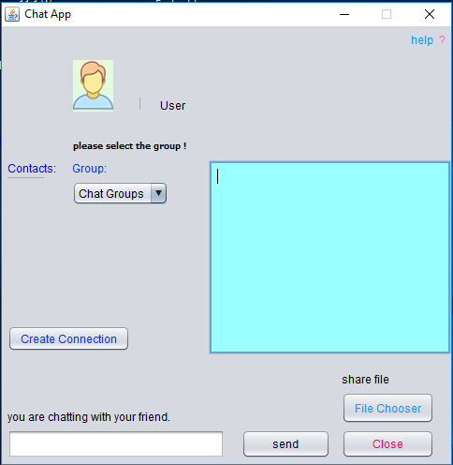

**Chatter_client.**

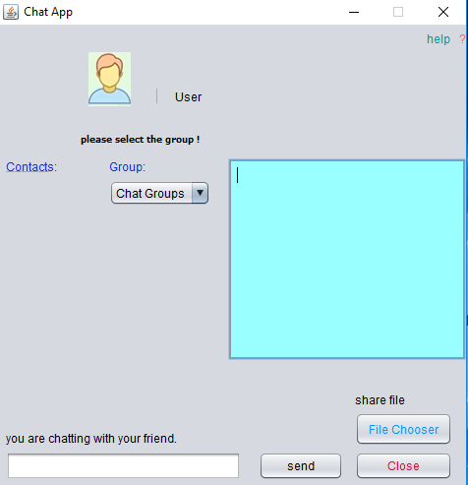

**While Chatting.**

